Group 9 System requirements analysis specification

Under revision [√]

Current version: 1.0.0

Author: Group 9

Reviser: LvChaoran 17206149

Revision date: 2020.3.17

Frist part: introduction

1. About project

Project name:

The Healing Paws Veterinary Hospital management system.

Background of development:

Management information system can be defined as a man-machine system composed of people and computer systems that can manage some information. The system can reflects the production and operation of the enterprise, uses past and current data to predict the future, and assists the enterprise in managing the situation from a global perspective.

This management system is for an animal hospital which only treats dogs and cats. They are currently transferring all operating procedures from the outdated paper system to a complete computerized system.

1. Document introduction

This document comprehensively describes all the requirements of the system and requirements analysis documents. It can be used to guide the system design and testing phases of the software development.

Second part: functions

1. Function introduction:
2. The system can let users select the location of the three cities when booking: Beijing, Shanghai and Chengdu.
3. Employees can add a new customer to the system through operations.
4. Employees can browse pet-related information.
5. Employees can update pet-related information.
6. Employees can add a new pet to the system through the user's commission.
7. Employees can browse pet's visit history.
8. Users can browse the clinic's veterinarians and their expertise.
9. The system needs to allow users to use online booking.
10. Managers or employees can view information about pet owners.
11. The system provides customers with the ability to schedule appointments for pets, including two types of appointments: emergency and standard.
12. During an appointment, system allows users to take more than one pets.
13. The system can update information about pet owners.
14. Customers can check the status of pets if they in terrible situations any time they need. For example, the date of the operation determined, the time operation completed, and the time of pet for release.
15. Employees need to have the ability to prioritize and track pets information in the system.
16. Customers can ask employees questions in some way in the system and employees can answer user questions.
17. The system should have two different systems, one for customers and one for employees.
18. The system need offer the ability of users and employees to interact with the new solution in English or Chinese.
19. User environment

A computer with internet connection.

Third part: requirements analysis

1. use case diagram

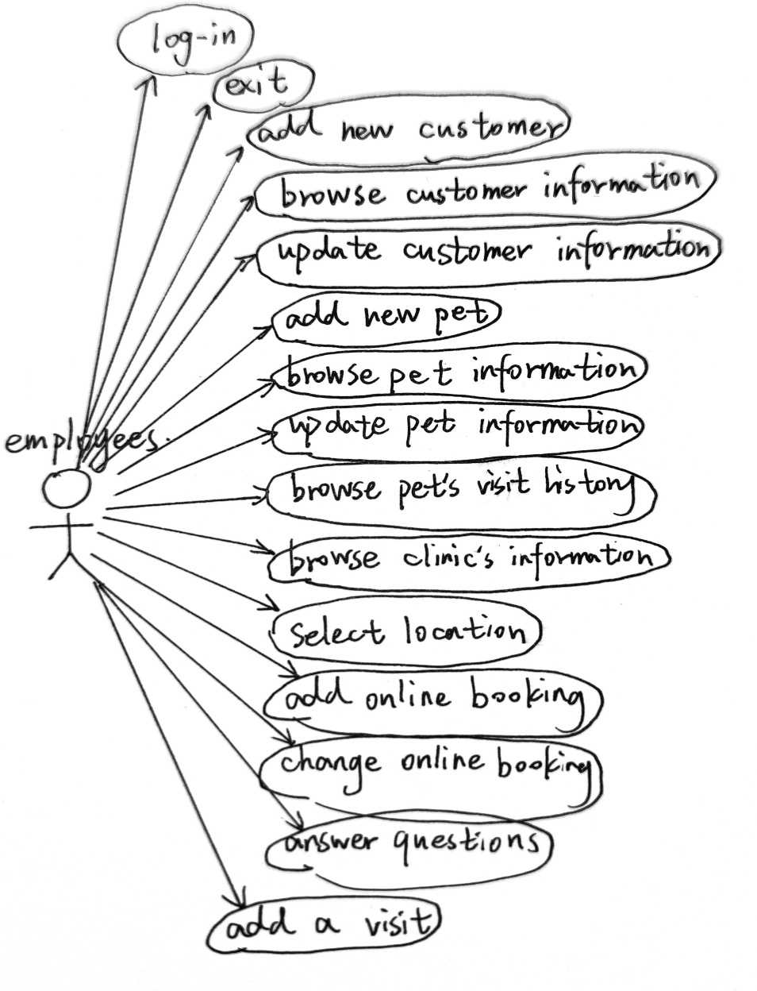

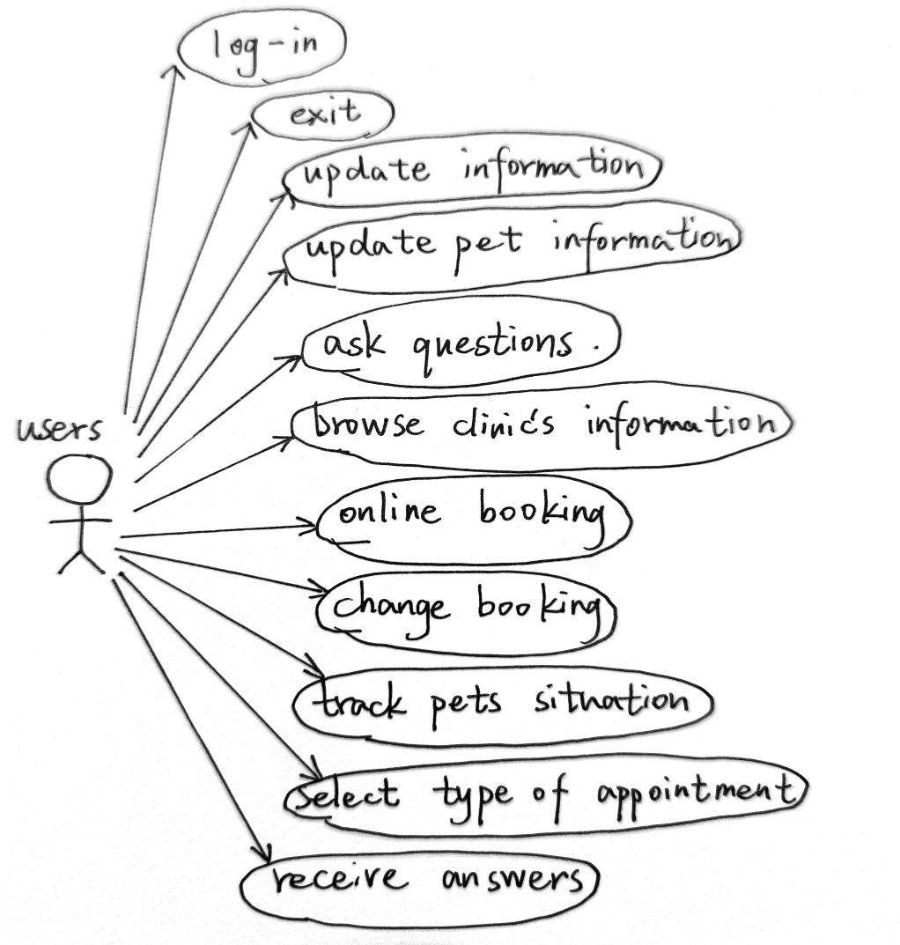

1. use case description

For employees:

Log-in:

Open the browser, the login interface is displayed in the browser, after entering the user name and password, submit the page. The system will verify the employee's login: If the user name or password is incorrect, the system displays "Login failed" and the employee can log in again, if the user name and password are correct, the employee logs in successfully.

Log-out:

After the employee logs in to the system and clicks the "Exit" button, the system presents the Log-in interface to the user, which allows him to log in to the system again and prompts the user with the message "Exit successfully".

Browse clinic’s information:

The staff enters the interface for browsing veterinary information, enters the name or specialty of the veterinarian, and clicks the "Query" button. The system finds out information about qualified veterinarians and their specialties, and presents a query result page for the staff to browse relevant information.

Browse customer information:

The employee opens the interface for querying pets and users, enters a name, and clicks the "Query" button. The system finds the pet owner that meets the conditions, and presents a query result page for the employee to browse relevant information. Staff can check not only the pet owner, but also pets belonging to the owner. The staff clicks a link to the pet owner will find the pet owner's detailed information: name, address, city, and phone number.

Browse pet information:

This use case shares a same interface with the "browse customer information" use case. The employee opens the interface for querying pets and users, enters a name, and clicks the "Query" button. The system finds the pet and it owner that meets the conditions, and presents a query result page for the employee to browse relevant information.

Update customer information:

When the staff browses the pet owner's information, they can modify the information at the same time by click the "Modify" button. The system will update the relevant information in the database, present the modification page again, and prompt the user with the message "Successfully modified."

Update pet information:

The staff can modify the pet's information when they browse the pet information. By clicking the "Modify" button, the system will present a page to edit the pet's information. The staff can modify the pet's name and type and date of birth also related information, when finishing modify, the employee will prompted with the message "Pet information modified successfully."

Add new customer:

Employee enters the name, address, city, and phone number of the new customer, and clicks the "Add" button, the system prompts the user with the message "Information inserted successfully" after the new customer information is successfully added.

Add new pet:

Employees browse the customer name and select one owner, enter name, type and date of birth also related information of the pet and last enter “Add pet” button to finish.